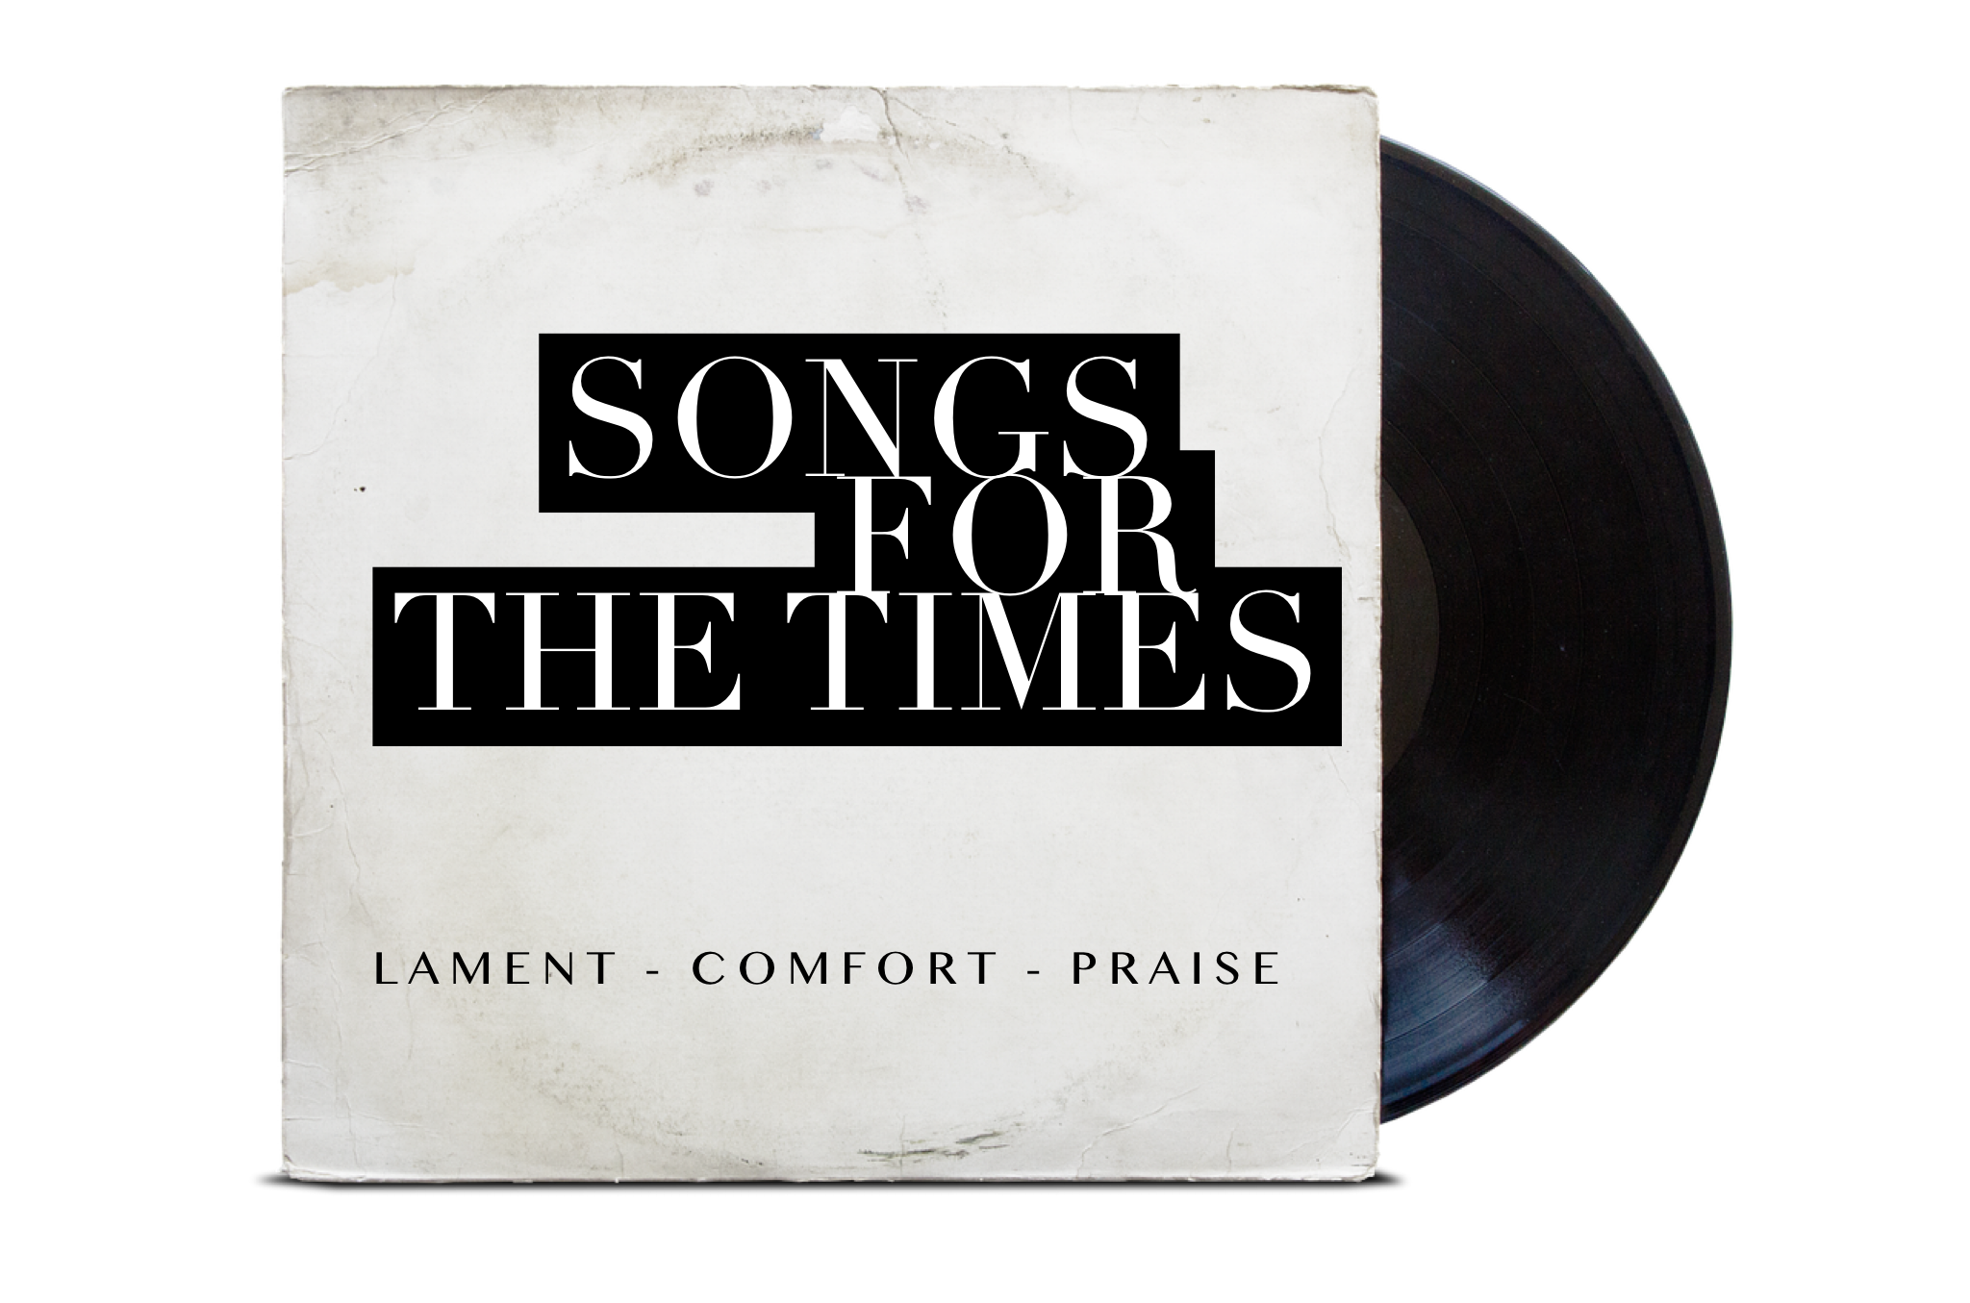

To begin:
Have one group member read Psalm 115.
Then allow 1 minute of silent reflection.

1. What is this psalm telling its hearers to do?
Which verses have the main exhortation?

A rough concentric structure to the psalm:
- Glory to the Lord (v1)
  - Where the LORD is (vv2-3)
      - What idols are like (vv4-8)
        - Trust in the LORD! (vv9-11)
      - What the LORD is like (vv12-15)
  - Where the LORD is (v16)
- Praise to the Lord (vv17-18)

Look at verse 2.
2. Why would the nations be saying “where is their God”? Think about the history of Israel, and the worship practices of Israel and the surrounding nations.

3. What examples of similar mocking of God’s people can you think of today?

Look at verses 4-8
4. According to the psalm, what are the downsides of being an idol?
5. What’s the downside of making and trusting idols?

6. An idol is “a good thing that gets turned into a god thing” - a created thing we look to for security and significance instead of the creator God. These days in the West we don’t tend to have little statues, but nevertheless many things function as idols. What idols are common today? Which ones do you find yourself trusting in?

Look at the whole psalm.
7. How is the LORD different to idols? List the things that contrast with verses 4-8

8. In light of the New Testament, how has the LORD ultimately remembered and blessed his people? How do verses 17-18 shine more brightly now that Jesus has come?

9. In our context, as we wait for God’s kingdom to come, what will it look like for us to trust in the LORD instead of idols?
To finish:
Have somebody praise God for the things
revealed about him in this psalm.
Close by praying verse 1 out loud.

